MODULE 4 – INTRODUCTION TO DBMS

LAB EXERCISES

4. Main SQL Commands and Sub Commands – DDL
Lab 1.
Create a table courses with columns – course_id, course_name and course_creates. Set the course_id as the primary key.
Ans.
1. CREATE TABLE courses(course_id int PRIMARY KEY , course_name varchar(255), course_credit varchar(255));
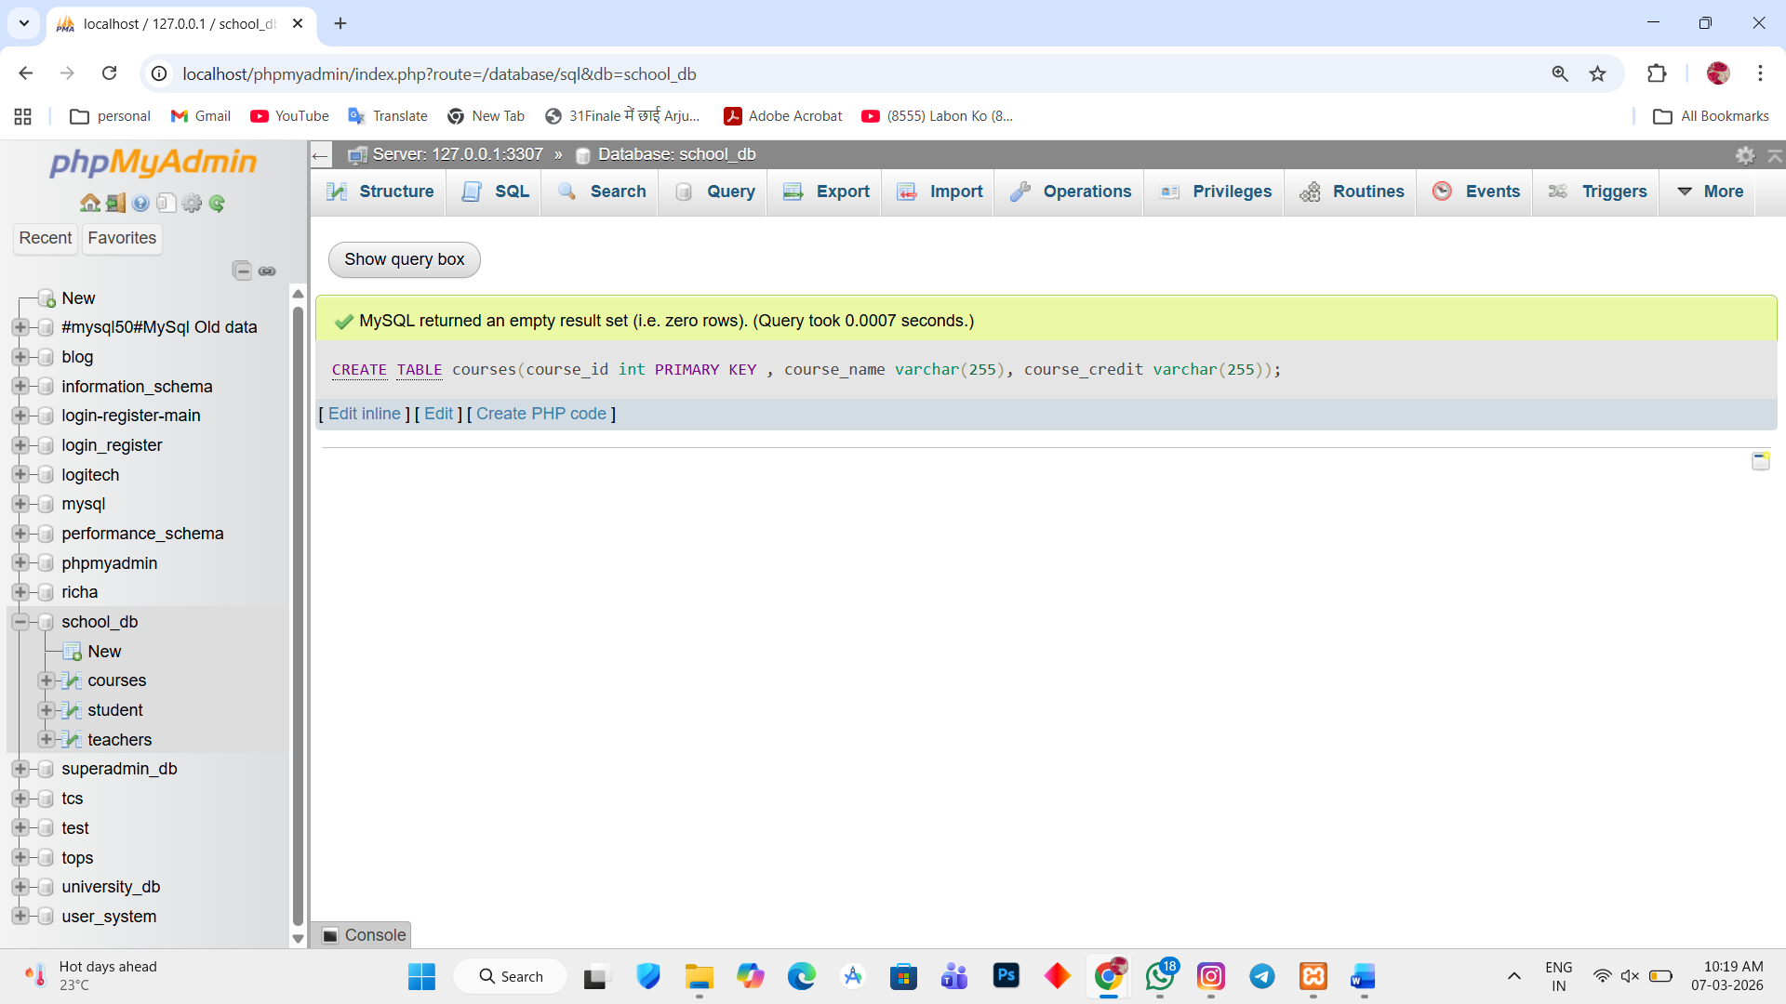

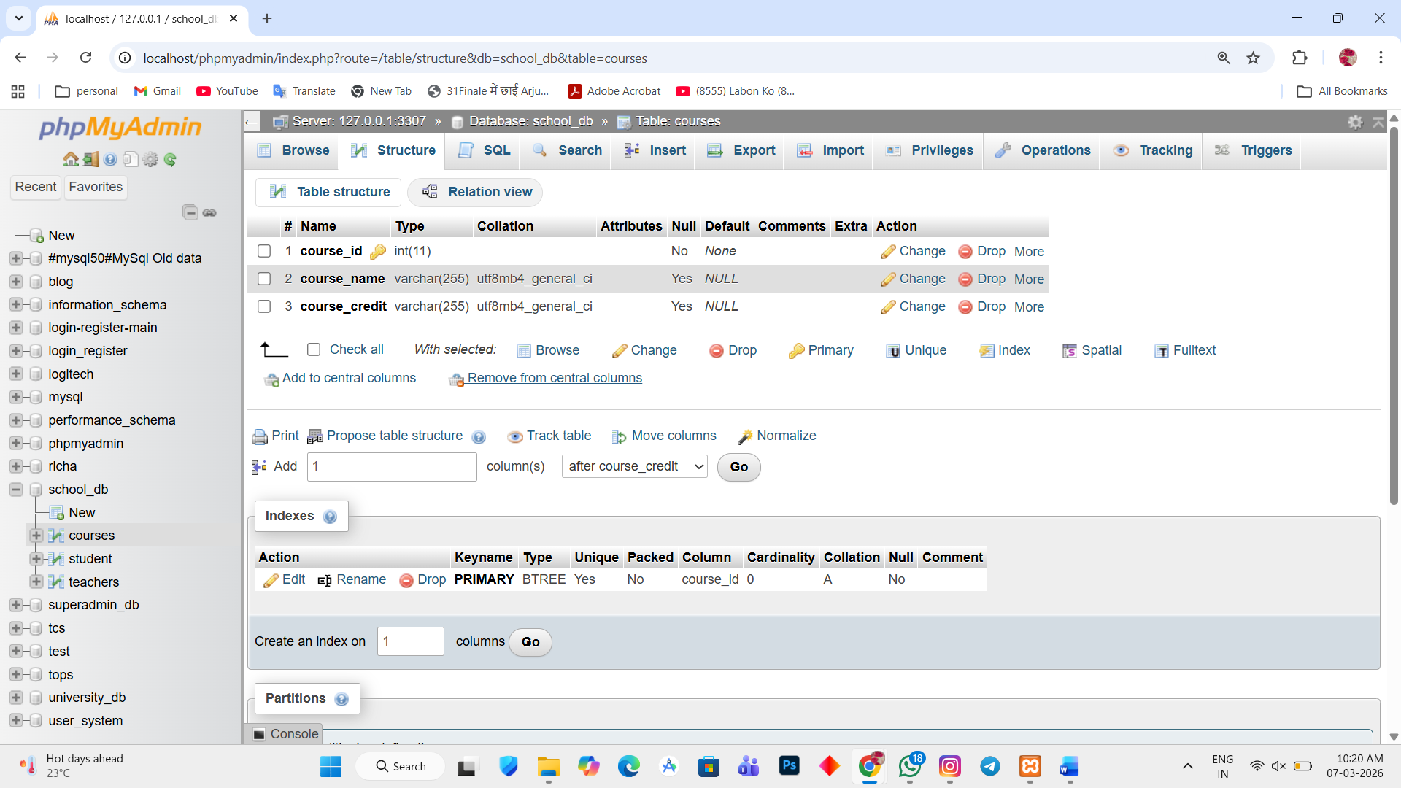

Lab 2.
Use the CREATE command to create a database university_db.
Ans.
1. CREATE DATABASE university_db
